**COMPUTERIZED PENSION VERIFICATION SYSTEM**

**BY**

**OLOJEDE ADEBIMPE RACHAEL**

**14/CSH/0612**

**BEING A SEMINAR PAPER SUBMITTED TO THE DEPARTMENT OF COMPUTER SCIENCE, FACULTY OF INFORMATION AND COMMUNICATION TECHNOLOGY,OSUN STATE POLYTECHNIC, IREE**

**IN PARTIAL FULFILMENT OF THE REQUIREMEN FOR THR AWARD OF HIGHER NATIONAL DIPLOMA (HND) IN COMPUTER SCIENCE, OSUN STATE POLYTECHNIC, IREE**

**DECEMBER 2016**

**CERTIFICATION**

This is to certify that this seminar work was carried out by **OLOJEDE ADEBIMPE RACHAEL** with matriculation NO: **14/CSH/0612** in the Department of Computer Science, Faculty of Information and Communication Technology, Osun State Polytechnic, Iree, Osun State in partial fulfillment of the requirements for the award of Higher National Diploma (HND).

**____________________ ______________________**

**Mr O. A. Oduwole Date**

**Project Supervisor**

**____________________ ______________________**

**Mr S. F. Oladoye Date**

**Head of Department**

**ABSTRACT**

Pension generally is a way of catering for the welfare of retirees. It is a periodic income or annuity payment made at or after retirement to employees who has become eligible for benefits through age, earnings and service. Pension verification system is a way of enrolling and verifying the pensioners. Investigation has revealed that there is no effective system for resolving the problem associated with the way of verifying . The study evaluates pension fund administration in Nigeria by examining the extent of compliance by employer of labour in funding the Retirement Savings Account (RSA) of their employees as a requirement of the new contributory pension scheme in Nigeria. Key problems facing pension scheme in Nigeria was identified with an overview of the scheme. In this paper,we consider the development of a computerized pension verification system designed to ease the pension board and the pensioners to be able to verify effectively. Real life preparation cases tested with the pension verification system showed high success (95%) between the developed system and the old system. This proved that the developed system is successful and promising.

Key Words: Pension verification system, Pension Fund Administrator, Pension Reform Act, Retirement Savings Account.

**INTRODUCTION**

Many countries have opted for various forms of contributory pension scheme where employers and their employees are supposed to pay a certain percentage of the employee’s monthly earnings to a retirement savings accounts from which they would be drawing their pension benefits after retirement. Besides pension funds are now among the most important institutional

investment in the world capital markets (Klumpes and Mason, 2000).Nigeria adopted for the contributory pension scheme following her pensions reform in 2004.Pension is the amount paid by government or company to an employee after working for some specific period of time, considered too old or ill to work or have reached the statutory age of retirement. It is monthly sum paid to a retired officer until death because the officer has worked with the organiza

tion paying the sum (Adam, 2005:468).Pension is also the method whereby a person pays into pension scheme a proportion of his earnings during his working life. The contributions provide an income (or pension) on retirement that is treated as earned income.This is taxed at the investors’ marginal rate of income tax. On the other hand, gratuity is a lump sum of money payable to a retiring officer who has served for a minimum period of term year (now five years with effect from 1/6/92). A greater importance has been given to pension and gratuity by employers because of the belief that if employees’ future needs are guaranteed, their fears amelioratedand properly taken care of,they will be more motivated to contribute positively to organization’s output. Similarly various governments’ organizations as well as labour union have emphasized the need for sound, good and workable pension scheme (Adebayo, 2006, Rabelo, 2002).The objective of this paper is to consider the pension scheme in Nigeria by comparing the old scheme with the new pension scheme which came into existence through the Pension Reforms Act of 2004.The first part of the paper considers a brief history of the pension system in Nigeria. Thereafter, the problems and characteristic features associated with the old pension scheme is examined.In the next section, the Pension Reform Act of 2004 is explored in great detail by looking at some of the provisions.

**LITERATURE REVIEW**

**History of the Nigerian Pension Industry**

One of the oldest documents to discuss social support was the Code of Hammurability by King Hammurabus of Babylon in the 18th century (Momoh and Idomeh ,2008). For instance, the code defined the rights of evildoers and orphans to the estates of their relations. According to Bloom (2005), one of the first publicly financed social security systems was developed in the late 16th century in England from a series of legislature Acts known as “poor laws”. Under these laws, local governments built large alms-house facilities that housed the people too old or unfit for work. Poor laws also established work houses and facilitated public housing for the employed. Moreover, these laws gave rise to the social insurance in Europe and social security in the United States (Momoh and Idomeh , 2008)The pension system was introduced into Nigeria

by the Colonial Administration. The first legislative document on pension in Nigeria was the 1951 Pension Ordinance which has retroactive effect from January 1, 1946. The Ordinance provided public servants with both pension and gratuity (Ahmed, 2006).The National Provident Fund (NPF) scheme established in 1961 was the first legislation to address pension matters of private organizations in Nigeria. This was the first social protection scheme for the non- pensionable private sector employees in Nigeria. It was mainly a saving scheme where both employee and employer contributed the sum of N4 each on monthly basis. The scheme provided for only one off lump sum benefit (Ahmad, 2006).The NPF was followed by Armed Forces Pension Acts No 103 also of 1972 and by the Pension Acts No. 102 of 1979,18 years later .The Pension Acts N 102 of 1976 which commencedon 1st April, 1974 encompassedthe recommendation of Udoji Commission which included all consolidated enact ments and circulars on pension as well as repealing existing 113 pension laws hitherto in force. Other Pension Acts included: Pension Rights of Judges Act No 5 of 1985, the Police and other Government Agencies Pension Scheme enacted under Pension Acts No.75 of 1987 and the Local Government Pension edict which culminated in the setting of the Local Government Staff Pension Board of 1987.In 1993, the National Social Insurance Trust Fund (NSITF) scheme was set up by Decree

No. 73 of 1993 to replace the defunct NPF scheme with effect from 1st July 1994 to cater for employees in private sector of the economy against laws of employment men in old age, invalidity or death (Balogun, 2006).In 1997, parastatals were allowed to have individual pension arrangements for their staff and appoint Boards of Trustees (BOT) to administer their pension plans as specified in the Standard Trust Deed and Rules prepared by the Office of Head of Service of the Federation. Each BOT was free to decide on whether to mention an insured scheme or self-administered arrangement. It must be recall that the first private sector pension scheme in Nigeria set up for the employees of the Nigerian Breweries was in 1954.The United African Company (UAC) scheme followed in 1957.

**Types of Pension Fund**

According to Ozor (2006), Pension consists of lump sum payment paid to an employee upon his disengagement from active service. According to him, payment is usually in monthly installments. He further stated that pension plans may be contributory on non-contributory; fixed or variable benefits; group or individual; insured or trustee; private or public, and single or multi-employer.Ugwu (2006) stated that there are four main classifications of pensions in Nigeria. These are:

1.**Retiring Pension**: This type of pension is usually granted to a worker who is permitted to retire after completing a fixed period of quality service usually 30 to 35 years or on attaining the age of 60 to 65 years for the public service in Nigeria and 70 years of age for professorsand judges.

2.**Compensatory Pension**:This type of pension is granted to a worker whose permanent post is abolished and government is unable to provide him with suitable alternative employment.

3.**Superannuating Pension**: This type of pension plan is given to a worker who retires at the prescribed age limit as stated in the condition of service.

4.**Compassionate Allowance**:This happens when pension is not admissible or allowed on account of a public servants removal from service for misconduct, insolvency or incompetence or inefficiency (Amujiri, 2009:140).

Pension may be provided by one or other of the three sources, the state, the insurance companies and private superannuating schemes. The pension scheme continued to develop.

Pension was found adequate to take care of bereaved members of the family of a deceased officer. Among other reports in this regard a committee was established by the then British government headed by Sir Alfred W. Walson, K.C.B. and nine other members to review the existing arrangement for the grant of pensions to the widows and to make recommendation as to any charges in the present policy in this matter which colonial government should be advised to adopt with special reference to:

(i) The classes of officials to be covered

(ii) The benefits to be afforded

(iii) The nature of the functional provisions to be made.

Provisions for grant of pensions to the widows and orphans of deceased officers in the colonial service was first made in British in 1873. It had felt that owning to the high cost of living in that colony, it was impossible for their family, more especially in the case of where an officer died early in his career, and there had been numerous cases of public officers being left destitute. A petition was submitted to the Governor by the officers of the colony in 1871 praying that some moderate provisions for widows and orphans. It was appointed out that courses to life assurance as a means of making provisions for widows and children was virtual almost impossible owning to the exceptionally high rate of premium charged on account of supposed unhealthiness of the climate.

This plea was listened to by the then Governor in May 29, 1871. A report was made in this regard in March 1872. Fund was passed in the colonial legislative in 1873. Funds were taken set up in other West Indian colonials (elgl Jamaica in 1875, Trinielad in 1890) and some in Eastern colonials Eceylon 1885, straits settlement in 1885, Martius in 1886, Hong Kong 1890) and cut across all the British colonials. From the above developments, it could be seen that every aspect of the pension scheme valued with compassion to events, which took place at any point time. The administrators of the then colonials were closely advising the government on what to do to achieve a good working scheme. Those were done through memoranda facts finding committee . Their recommendations are passed over to the legislator’s Bill for enactment of the enabling laws. By the process management development procedures, polices and objectives are fashioned out to suit the scheme in accordance with the operational factors.

**Pension Acts in** **Nigeria**

The need for legal provisions for the establishment and administration of pension scheme are to ensure uniformity and consistency, notwithstanding, in the implementation of the program. Ebeguna (2000) in his contributions opined that a pension scheme therefore makes provisions for both legal and administrative procedures and processes that will facilitate the realization of the objective.

In Nigeria such enabling legislation include the pension increase Decree No. 42, 1975:

(a) Military Pension Act Cap (Chapter or No.) 119.

(b) Pensions Act Cap (Chapter or No) 147.

(c) War Pension Act Cap (chapter or no) 212.

(d) Pension (special pensions) Act 1961 (chapter or no) 1961 no. 15.

(e) Widows and orphans pension Act Cap 220.

(f) Pensions (Statutory Corporation Service) Act 1961 no. 61.

(g) Pension (Transferred Services) Act 1965 no. 28.

(h) Special Constables Decree 1966 no. 7.

(i) Police Pension Decree 1966 no. 60.

(j) Pensions (Federal Fire Service etc) Decree 1966 no. 74.

(k) Pensions gratuities (war service) Decree 1966 no. 49.

(l) Transferred offices and pension liability 1971 no. 8.

(m) Military pensions (Amendments) Decree 1975 no. 13 by Mohammed, head of the Federal Military Government, Commander-in-Chief of the Armed Forces FRON 20/12/75.

(n) The Pensions Act of 1979 Decree No. 102, which awarded and united all pensions, acts.

(o) The Public services the recommendation review 1974.

(p) The armed forces pension act no. 103 of 1974.

(q) The pension rights judges Act no. 5 of 1985 and

(r) The amendment Act no. 51 of 1988, 29 of 1991 and 62 of 1991.

The whole of the ordinance acts and Decree is capped up in the Decree No. 102 of 1979, which took effect from 1st April, 1974. It consolidated all enactments on pensions and in corporate pension and gratuities seals devised for public officers by the Udeorji Public Service Review Concision in 1974. In the same way, Pension Act No. 103 of 1979 like its counterpart Decree No. 102, of 1979 on the other hand dealt with pension benefits, liabilities and seals devised for the agreed forces.

The root of these laws were derived from:

(a) The British Laws Act of Parliament 1834 for meritorious services.

(b) The British National Insurance Act of 1959 for National Old age and widows pensions.

(c) The British Finance Act 1956, which introduced special new law whereby the self-employed persons, could join together in pension arrangement with its advantages.

(d) The Act of 1951 – pension ordinance which took effect from 1st January 1946, its aim was to achieve a continuous service to those serving in the British colonies. The application of pension benefits was at the pleasure and discretion of the governed of the colonies for the indigenous workers e.g. Nigerians.

**Record Management and Administration of Pensions in Nigeria**

This is a process, which connects, record creation, record processing, records use and maintenance, records protection or preservation, and records disposition. In this discussion, Salami (2000) noted that records consist of correspondence, forms, maps, plans and other documents books, photographs, films, some recordings, paper and magnetic tapes, computer cards and dies or other documentary materials which:

(a) Are made or received by government ministry/agency in the course of an administrative or executive transaction.

(b) Are preserved as appropriate for the use of that ministry or its legitimate successor and

(c) Contain evidence of its functions.

Policies, decisions, operations or other activities or information of values to the Government, in short, records includes all transactions of an agency within or without that used in performing its functions, kept for future references, maintenance of the agency’s history to ensure it continued in existence.

In his response as to “what is records management, record management is a planned programme for the creation, maintenance of records. In other words, the record management programme is interested in the records right from its creation use and final disposition.

In this connection, records management and administration of pension in Nigeria deals with the collections of the relevant information which affect the individual service. Such facts in all its form have to be stored and readily repairable for information and preservation against damages. This is kept in this registry till the end of officer’s service. The records are even kept belong such time as reference are made to it from time to time. Trained officers could be given appointments on contact and recompilation of benefit may occur due to areas of promotions.

Salami (2000) continued “what is registry”? He explained that according to modern archival terminology provided by UNESCO, a registry refers to a unit of an agency, institution or organization responsible for the creation, control and maintenance of current files and records. All government ministries agencies are served by registry practice could not be over emphasized registries is therefore the basic tools or instruments by which an organization carries out its functions and processes. If records are well managed the effectiveness of government is enhanced, government programs becomes more responsive. It is therefore essential that all ministries/agencies etc. should have sound and consistent procedures for looking after their records and locating correspondence and other communication when they are required.

Files are the means in which this is done. A file is defined in registry as an organized unit (folder, volume etc) of document group together either for current use or in the process of archival arrangement; it is a basic tool of any registry. Files should be induced by assigning reference number to files.

For the administration to be effective, the following records are to be kept with the ministry of establishment and bound by a binding and kept at the central registry:

(a) Letter of Appointment

(b) Letter of acceptance of offer of appointment

(c) Copies of academic or educational credentials and testimonials.

(d) Certified true copy of the officer’s record of services.

(e) Medical certificate of fitness.

Those are ultimately used in processing the retirement benefits of all officers the retirement benefits of all officers when they retire.

For the purpose of emphasis, record of service include all names of an employee, starting with the surname, 1st day of assumption of duty so as to ensure the proper identification of the employee.

(i) Marriage certificate or

(ii) Sworn affidavit on dissolution of marriage if marriage is dissolved or

(iii) Sworn affidavit on change of name

(iv) Newspaper adjustment on any of the widely read dailies.

(v) The date of birth enables the employer to know whether an officer should be given a permanent or contract appointment at the point of entry into the federal services.

The particulars of children is important act to pension administration as well as officer who so on duty tours/postings abroad updating of records on children is done in the office of the head of service by forwarding through the appropriate ministries the birth certificate of children of officers.

Details of progress in service are also next of kin. It is advised that officers should take another look at that record of service and check the suitability or otherwise of these indicated next of kin. Where there are discrepancies, the beneficiaries are required to tend a letter of administration. The service must not be broken or where it is, the break has to be condoned wish an approval from officers of the head of civil service of the federation. It is pertinent to note that even after leaving the service an office’s record of service may still be required for other purposes, which include research today, the registry the same. There are so many problems with records scattered all over the places. Virtually every year by year, coders are asked to produce their record of service.

There are many inexperienced people dumped in the registry. Deployment there is mainly a punitive measure against some personal staff.

Enough budgetary allocation is not made for the registry. It has a very little space with dust fire and ruined by the rain due to the leakage of unrepaired dilapidated roofs where files are stored, bad lighting system and lack of ventilation with occasionally bad sight to the workers and other effects.

Records are not found in fact, records are not organized. Training programs are no longer given to the workers. The registry is in shamble.

There is need for the use of the modern technology computer by the registry. The records service carefully and skillfully packaged; easily retrieval updated and safely kept. Raining in-service, study leave, seminar, workshops and other training programme would be necessary to live up to the present demands of the registry.

**THE EXISTING PENSION VERIFICATION SYSTEM**

Investigation has revealed that Pension Fund Administrator (PFA) find it difficult to verify and detect those pensioners who are alive since there is no continuous verification system which will allow the pensioners to update their data either monthly or annually.

According to the workers in the Pension Board, One of the major problems involve is the long queue of the pensioners who comes for the manual continuous verification process which is not in the current system, the processing could take place for days. It is the part of an individual involved to submit all the necessary requirement. Other problems since there are a lot of document needed from an individual then going through all the documents seems to be a very tedious exercise to the worker, problems of manual verification of the pensioners and this result in the inability to keep accurate record of an individual in this case, a lot of people normally falsely their age, inability to maintain first serve due to the large quantity of files. (Orifowomo, 2006).Sadly, retirees went through tough times and rigorous processes before they were eventually paid their pensions, gratuity and other retirement benefits

.At one time the money to pay their benefits is not available; and at another time, the Pension Fund Administrators were not there to meet the retirees’needs. Basically, the old scheme has been beset with a lot of challenges and problems. Besides the aforementioned; other problems were: demographic challenges and funding of outstanding pensions and gratuities, merging of service for the purpose of computing retirement benefits. These problems coupled with the administrative bottlenecks, bureaucracies, corrupt tendencies and inefficiencies of the civil service, and the economic down turn have resulted in erratic and the non-payment of terminal benefits as at when due (Orifowomo, 2006;Ezeala, 2007, Abade, 2004).Other problems were: gross abuse of pensioners and pension fund benefits which were politically motivated in some cases,

**THE NEWLY DEVELOPED PENSION VERIFICATION SYSTEM**

The newly developed system allows continuous verifications for already verified pensioners whose records and biometrics have been inputted into the database with a view to determining their alive status. Such verification will be conducted annually, in the minimum. To this end the PFA have put in place a system for continually verifying already enrolled pensioners. Such a system allows for the verification of pensioners at their own convenience and should be based on their presentation of an approved mode of identification at their various pay points i.e. banks. The new system allows the Pensioners Payroll to be updated which reflect the outcomes of such continuous verifications. It ensure that all pensioners who are not so verified are suspended from the payroll pending the confirmation of their aliveness or otherwise.

It is believed that the new system will: guarantee the prompt payment of pensions to retirees, eliminate queues of aged pensioners standing hours and days in the sun to collect their pensions and also increase their standard of living.

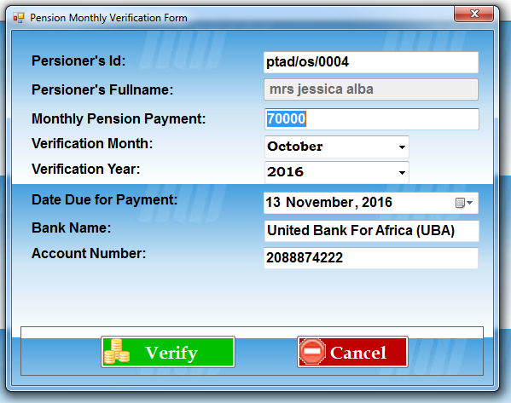

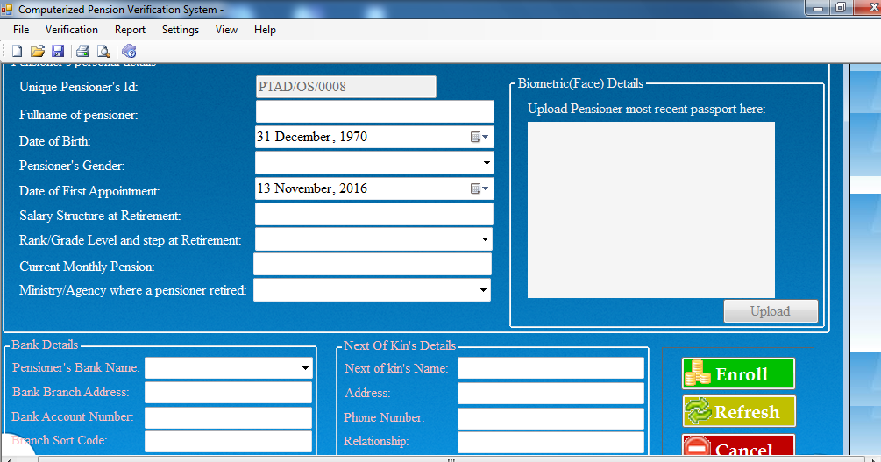

**RESULT AND DISCUSSION**

The result of evaluation of the developed system showed that 26 out of 30 users agreed that the system is usable. Also 26 out of 30 users agreed that the system is accessible. This number shows that the newly developed system is successful and going in the correct direction. it is then concluded that in this work a computerized pension verification that is capable of ensuring speedy and accessible means of verifying pensioners has been developed

**CONCLUSION AND RECOMMENDATION**

In this research, a pension verification system has been designed and developed based on computerize pension verification system. The system is robust, safe and poised to help retirees live well after their active life in service. The system has a graphical user interface and simple pages: information is displayed in a way that is familiar for pensioners. The features of the developed system were discussed and illustrated with the pension verification system. The system is successful and efficient. Result and discussion reveal 95% of the system show an agreement between the newly developed system. The system can be improved further and the following recommendations are made for future work.

1. Currently the system only verify through the use of unique identification number which each pensioners have.It would be better to incorporate thumb print.

2. The system can be improved by having a mobile app for it which pensioners can always verify through.

**REFERENCE**

Adams, R.A. (2005): Public Sector Accounting and Finance, Lagos, Corporate Publisher Ventures.

Abade, R. (2004):Pension Reforms Act 2004:What’s in it for You? [www.Newage-](http://www.Newage-) online.com

Adebayo, Y.K. (2006): Essentials of Human Resource Management, Benin City, Weliscops services.

Ahmed, m. (2006): Meeting the Challenges of Human Capital Development in Nigeria: The Case for Reforms in our Educational Policies and System.

Amujiri, B.A. (2009). “The New Contributory Pension Scheme in Nigeria: A Critical Assessment, NJPALG, Vol. XIV No.1, pp.137 –152.

Balogun, A. (2006): Understanding the New Pension Reform Act (RRA, 2004)

CBN BullionVol. No 30, No. 2.

Ebeguna, L.D. (2000): Financial Reporting and Analysis; Pearson Educational Inc.,Upper Saddle Rivers, New Jersey.

Ozor, E. (2006). “Review of Factors that Slow Down the Processing of Retirement Benefits.”A Paper Presented at the Workshop Organized by the Institute of Chartered Secretaries and Administration of Nigeria, Held at Modotel Enugu, between 14th and 16th May.

Robelo, M.F. (2002): Comparative Regulation of Private Pension Plans.

salami, K. (2000): Pension Reforms in Nigeria: Transition from the Defined Benefits to Defined Contribution: A Paper Presented at the IOPS Workshop in Pension Supervision in Dakar on February 5, 2000.

Ugwu, D.S. (2006). Contributory Pension.” A New Approach to Financing Pension Scheme in Nigeria”. A Paper Presented at a Seminar Organized by Mokasha.

World Bank (2004): Pension Reform and the Development of Pension Systems: An Evaluation of the World Bank Assistance, Washington D.C.